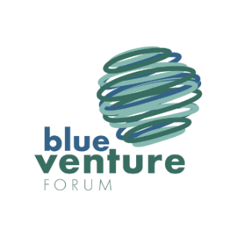
Blue Venture Investment Summit
9:30AM-6:30PM
8:00AM-8:30AM Registration

8:30AM-8:40AM Welcome and Introductions

8:40AM-9:00AM Opening Keynote

9:00AM-10:00AM Blue Technology Investing Today

10:00AM-10:30AM Networking Break

10:30AM-11:30AM Maine, A Case Study in Supporting and Growing a Blue Economy Ecosystem

11:30AM-12:15PM Flashtalks: Global Innovators and Entrepreneurs
12:15PM-1:00PM Lunch
1:00PM-2:00PM Raising an investment round in today’s environment
2:00PM-3:00PM Flashtalks: Global Innovators and Entrepreneurs
3:00PM-3:30PM Networking Break
3:30PM-4:15PM The Future of Investing in the Blue Economy

4:15PM-5:00PM Closing Speaker

5:00PM-6:30PM Closing Reception

